

**COMSATS University Islamabad (CUI)**

Project Proposal   
(SCOPE DOCUMENT)

For

YourCovid-19Assistant

Version 1.0 ***By***

**Hajira Mansoor CIIT/FA18-BSE-026/ISB**

**Sohaib Ahmad Khan CIIT/FA18-BSE-086/ISB**

***Supervisor*Mr. Tanveer Ahmed**

*Bachelor of Science in Software Engineering (2018-2022)*

**SCOPE DOCUMENT REVSION HISTORY**

|  |  |  |
| --- | --- | --- |
| **No.** | **Comment** | **Action** |
| 1 |  |  |
| 2 |  |  |
| 3 |  |  |
| 4 |  |  |
| 5 |  |  |
|  |  |  |

**Supervisor Signature:**

**Date:**

**Table of Content**

Abstract i

1 Introduction i

2 Problem Statement ii

3 Problem Solution for the Proposed System ii

4 Related System Analysis/Literature Review ii

5 Advantages/Benefits of YourCovid-19Assistant iii

6 Project Scope iii

7 System Limitations/Constraints v

8 Software Process Methodology v

9 Tools and Technologies v

10 Project Stakeholders and Roles v

11 Team Members Individual Tasks/Work Division vi

12 Data Gathering Approach vi

13 Concepts vi

14 Gantt chart vii

15 Mockups viii

16 Conclusion xiii

17 References xiii

18 Plagiarism Report xv

# 

**Project Category:**

* **C-** Problem Solving and Artificial Intelligence
* **E-** Smartphone Application
* **H-** Image Processing

# Abstract

Our health is our priority that we should take care of because on the day of Judgement we would be answerable about our body. As Covid-19 a deadly viral disease has spread worldwide. We need to take care of our health and others health also. There are number of people who died and are dying daily due to Covid-19. The virus Covid-19 is spreading at much higher speed that tracking it manually is almost near to impossible. As we mentioned it is a deadly disease and late treatment can lead to deaths.

Nowadays we are surrounded with technologies and it might help to make detection of diseases in real time. YourCovid-19Assistant, an AI based covid-19 detection system, will detect Covid-19 from Chest X-Ray Images using Deep Learning. In a user friendly environment, which will be available for Android Phones, the user will test their Chest X-Ray for Covid-19, will provide symptoms they have, based on the symptoms severity level the system will notify the user about taking help from medical specialist or taking good care of him/herself at home. The system will be able to give tips to Covid-19 patients to take good care of themselves at home. Hence YourCovid-19Assistant, will help users to detect Covid-19 without going to crowded hospitals, will help users save their time waiting for an appointment, will help user in treating Covid-19.

# Introduction

The novel coronavirus (Covid-19) is a viral disease that was first identified in Wuhan, China in 2019. It has led to many deaths and has stopped social and commercial activities of life that has badly affected countries badly. Covid-19 if not detected early can cause severe damage to lungs that lead to short breath and later to death. To perform this detection, we need to perform Covid-19 Swab Test that is time taken and also expensive. Another method to detect this is Chest X-Ray Images, that will be checked by medical specialist or radiologist who will identify Covid-19 symptoms in it but it is easily confusing with pneumonia. Consider that our 70% population is in rural areas they do not have direct access to Expensive Swab tests as they are performed in some of the laboratories in cities.

YourCovid-19Assistant will provide a mobile platform where Covid-19 can be detected by using Chest X-Ray Image with much accuracy almost up to 94%. Along with some other supporting features like AI-Powered Chatbot, Tips to treat Covid-19 at home. To help stop the spread of Covid-19.

# Problem Statement

The novel Corona Virus disease is one of the leading diseases that has spread worldwide, causing huge number of deaths daily. It has no clear symptoms, but some given by World Health Organization are fever, dry cough, tiredness, headache, loss of taste or smell, difficulty in breathing, chest pain, and loss of movement. Covid-19 is easily spreadable that’s why it is more dangerous. The main issue is that manual detection of it from Chest X-Ray Images is easily confusing with Pneumonia. And the Swab Tests are expensive and not available easily in laboratories. According to World Health Organization 3.49M people died from Covid-19 up till now in which 20,465 are from Pakistan.

# Problem Solution for the Proposed System

To solve the proposed problem, YourCovid-19Assistant will use deep learning techniques. YourCovid-19Assistant will get a Chest X-Ray Image uploaded from smartphone device and process it to explore that whether the patient has Covid-19 or not. This image can be taken from radiology labs easily.

The system will classify the CXR Image as normal or Covid-19. After this process, result will be generated for the user. Along with this YourCovid-19Assistant will provide helping the user chat with a chatbot that will help in keeping the user from boredom in quarantine. User will be able to enter daily symptoms and the system will predict to him daily health tips or will consider meeting medical specialist according to the severity level of the symptoms.

# Related System Analysis/Literature Review

In Pakistan there is only one existing system related to Covid-19 that has very limited functionality developed by Government of Pakistan. That only shows the user Positive Cases, Deaths, Recovered Patients rate provincially. It lacks in warning user that the user has met someone who is Covid-19 positive or having more likely symptoms. It lacks in detecting Covid-19.

This is also a new domain of study for us.

Table 1: Related System Analysis with YourCovid-19Assistant

|  |  |  |
| --- | --- | --- |
| **Application Name** | **Weakness** | **Proposed Project Solution** |
| * Covid-19 Gov PK | * Cannot detect Covid-19 * Chatbot not working * Not having health tips for treating Covid-19 at home | * Covid-19 Detection using Deep Learning * Workable chatbot * Health Tips to treat Covid-19 at home |
|  |  |  |

# Advantages/Benefits of YourCovid-19Assistant

The proposed system will not only detect Covid-19 but will also have user friendly chatbot with which user in quarantine can text and it will answer in well manner.

The system will also keep track of the symptoms of the user. The system will also give daily health tips to treat covid-19 at home. The proposed system will save a lot of time and money by not going through expensive lab tests that are not always true.

# Project Scope

YourCovid-19Assistant is proposed as a support for the government, doctors, and people as well by aiding them in detecting and treating covid-19, by keeping track of the patients. The user will use some of the features without creating an account that is testing CXR for covid-19. The user will browse for CXR Image and YourCovid-19Assistant will perform preprocessing steps, after which it will classify it as Covid-19 or normal. User can also benefit from our chatbot and daily health tips to treat covid-19 at home.

## Module 1: Detection of Covid-19

YourCovid-19Assistant detect covid-19 from chest X-Ray (CXR) image using a deep learning technique called convolutional neural network (CNN). We will use CovidX dataset which is an open access benchmark dataset comprising of 13,975 CXR images across 13,870 patient cases. [1]

### Module 1.1: Preprocessing and Model Training of Dataset

Preprocessing of data is very crucial part for any machine learning application. In this module, preprocessing is done on the available dataset through different techniques such as:

* **Data Cleaning:** The dataset should be cleaned of any missing values, as Dataset contains images and the related information about images is saved in a .csv file. The file may contain missing values.
* **Label-Encoding:** After that we must will label encode the columns which do not have numeric values. Because machine learning model requires numeric values to work on.
* **Image Preprocessing:** To upload images into the machine learning model we may resize the images, lower than their original dimensions. We will crop the outer extra areas from the CXR images for getting higher accuracy by avoiding the outside parts of the body.
* **Train-Test Split:** After that the dataset will be divided into training and testing set. Machine Learning model will be trained using training set and for validation testing set will be used.
* **Model Training:** A very popular deep learning technique, Convolutional Neural Network (CNN) will be used to train the model on the training dataset that we processed earlier in the pre-processing of module.

## Module 2: HowWeFeel

YourCovid-19Assistant check whether a person has developed any symptoms of Void-19 or not by collecting data from users such as heart rate, sleep patterns, body temperature, headache, body pain, etc. The results are displayed on an interactive online map that will allow health authorities to keep the required stock of the situation. This will help in monitoring the spread of coronavirus.

### Module 2.1: Generate Multiple Choice Questionnaire

In this module our app will generate a multiple-choice questionnaire that will contain all the possible symptoms given by WHO for Covid-19 patients. User will select the symptoms he/she have and the system will store it along with location data.

### Module 2.2: Radius Alert

In this module, our app will show user an interactive online map and will show hotspots in green and red color. Green color for the areas that are safe-zone means where Covid-19 ratio is less and red color spotted area showing danger alert the area having higher number of cases.

## Module 3: AI-Powered Chatbot

This module will provide the user a user-friendly chatting platform where the user will be able to chat with an AI-Powered Chatbot so that patient do not get bored in quarantine. “Some people genuinely dislike human interaction. Whenever they are forced to socialize or go to events that involve lots of people, they feel detached and awkward.” [2]

### Module 3.1: Chatbot Training

In this module we will train our Chatbot with dataset containing dialogues between covid-19 patients and normal people or doctor in natural language.

### Module 3.2: Build Deep Learning Model

In this module we will build a deep learning model using Keras to train a neural network on the data trained above.

## Module 4: Tips for Treating Covid-19 at Home

In this module we will generate health tips for Covid-19 patients on daily basis. It will generate a chart for the user that may contain food, drinks, and medicines list to take by the user on that day.

# System Limitations/Constraints

* Image quality must be good for accurate results
* The system will be available only for Android Phones

# Software Process Methodology

For developing our application, we will be using Modified Waterfall Model that is a modified version of the classical waterfall model. Unlike classical waterfall model in modified waterfall model, we can go back to a previous phase for verification or validation.

# Tools and Technologies

Table 2: Tools and Technologies for YourCovid-19Assistant

|  |  |  |  |
| --- | --- | --- | --- |
| **Tools**  **And**  **Technologies** | **Tools** | **Version** | **Rationale** |
| Android Studio | 4.2.1 | IDE |
| MongoDB | 4.4.4 | DBMS |
| MS Word | 2016 | Documentation |
| MS Power Point | 2016 | Presentation |
| MS Project | 2016 | WBS/Gantt Chart |
| MS Visio | 2016 | Diagrams |
| MockPlus | 3.6.2.2 | Mockups Creation |
| Anaconda | 2020.11 | Interpreter |
| Keras | --- | API |
| Tensorflow | --- | API |
| **Technology** | **Version** | **Rationale** |
| Kotlin | 1.5.0 | Programming language |
| NOSQL | -- | Query Language |
| Python | 3.8 | Programming language |
| Flask | -- | Deep learning API |

# Project Stakeholders and Roles

Table 3: Project Stakeholders for YourCovid-19Assistant

|  |  |
| --- | --- |
| **Project Sponsor** | ***COMSATS University Islamabad*** |
| **Stakeholder** | * Hajira Mansoor: Developer * Sohaib Ahmad Khan: Developer(Team Leader) * Mr. Tanveer Ahmed: Supervisor * Final Year Project Committee: Evaluation of project |

# Team Members Individual Tasks/Work Division

Table 4: Team Member Work Division for YourCovid-19Assistant

|  |  |  |
| --- | --- | --- |
| **Student Name** | **Student Registration Number** | **Responsibility/ Modules** |
| * ***Hajira Mansoor*** | * ***FA18-BSE-026*** | * ***Module 2: HowWeFeel*** * ***Module 4: Tips for Treating Covid-19 at Home*** |
| * ***Sohaib Ahmad Khan*** | * ***FA18-BSE-086*** | ***Module 1: Detection of Covid-19***  ***Module 3: AI-Powered Chatbot*** |

# Data Gathering Approach

We have explored the internet for free benchmarks to find available dataset for our system and found a reliable source,

1. COVIDx Dataset that contains 13,975 CXR Images across 13,870 cases, introduced by Wang Et. Al on paperswithcode.com

# Concepts

* **Machine Learning:** We will train our system using the concepts of machine learning to classify the Chest X-ray Images. We will also work on neural networks to improve the result.
* **Android Development:** YourCovid-19Assistant is an android application.
* **APIs Injection:** We will learn to implement APIs with our system because all the DB and backend will be handled through APIs from frontend.
* **Natural Language Processing:** We will learn about Natural Language Processing as our app contains AI-Powered Chatbot.

# Gantt chart

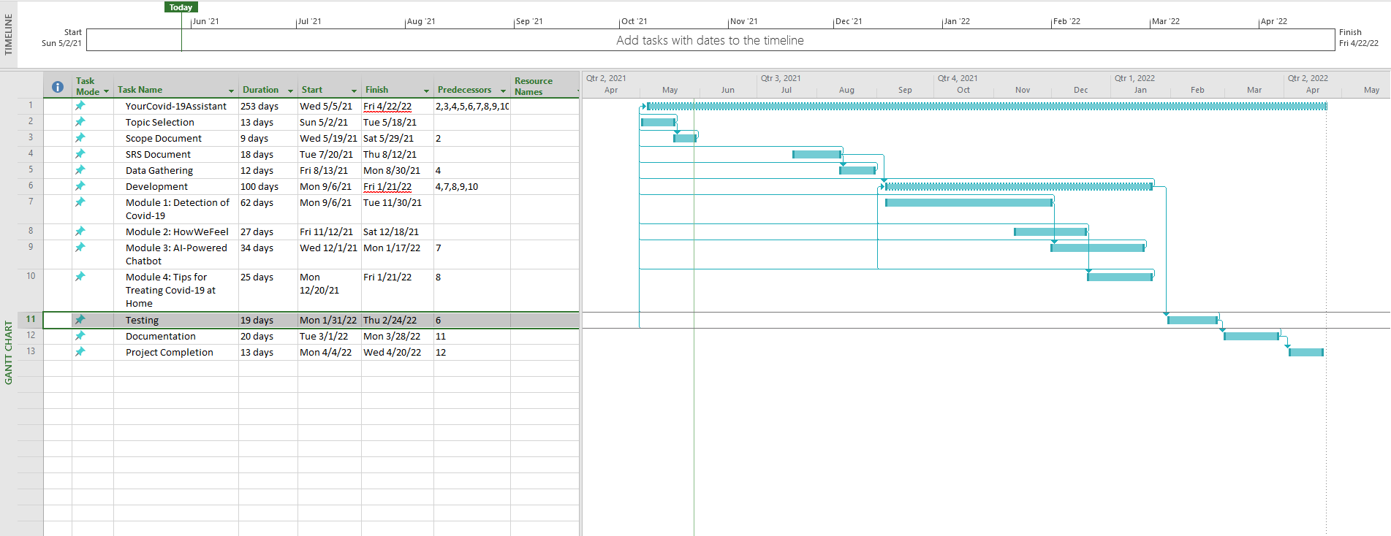

# Mockups

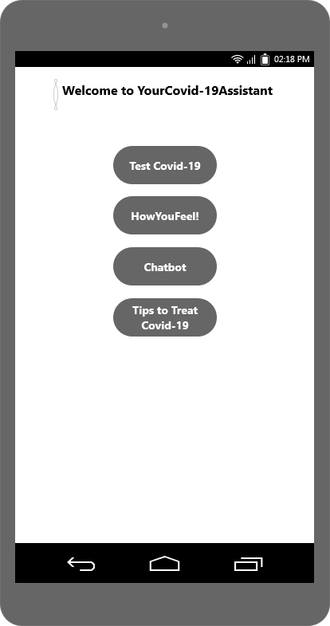

Figure 1: Home Page

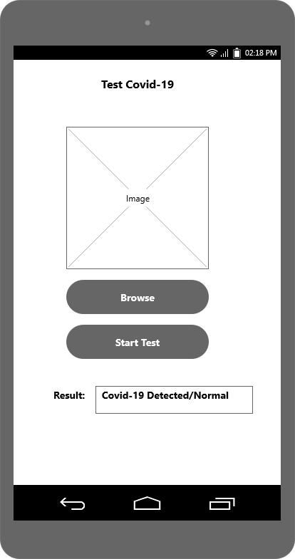

Figure 2: Test Covid-19

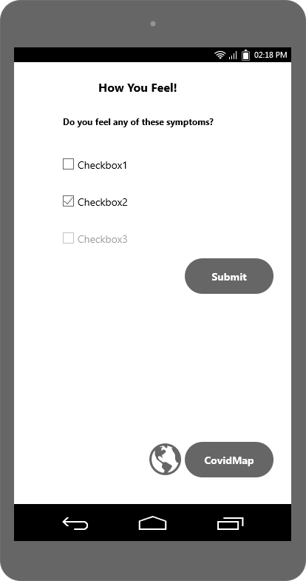

Figure 3: HowYouFeel

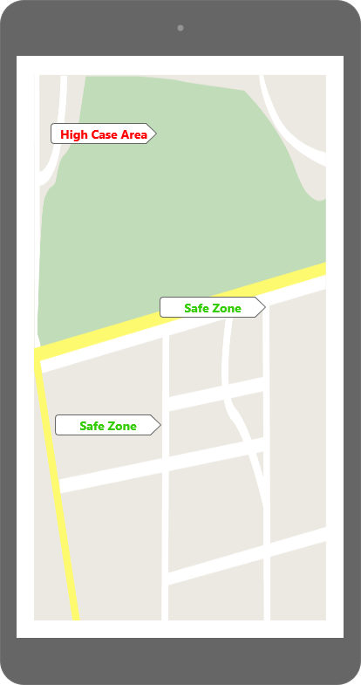

Figure 4: Covid Map

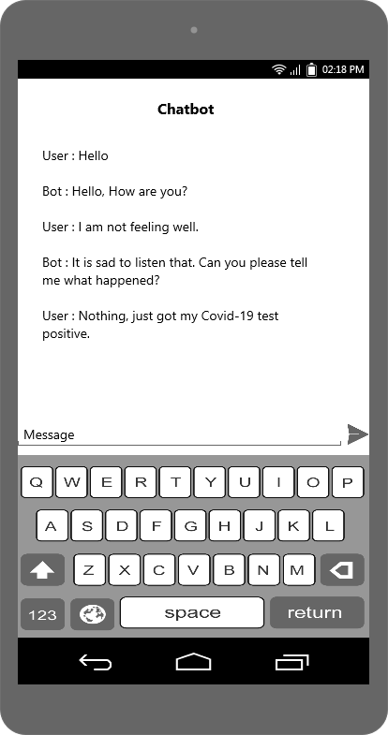

Figure 5: Chatbot

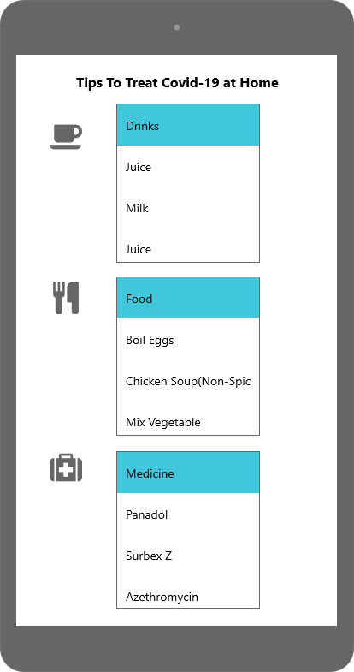

Figure 6: Tips to treat Covid-19 at Home

# Conclusion

YourCovid-19Assistant system will help in detecting covid-19 at home. It will help in stopping the spread of Covid-19. This system will help in suggesting health tips. This system will help to keep user entertained that quarantined patient cannot get bored and alone through AI-Powered Chatbot. It will save the user a lot of hospital and laboratory expenses and time.

# References

|  |  |
| --- | --- |
| [1] | W. e. al., "COVIDx," paperswithcode, [Online]. Available: https://paperswithcode.com/dataset/covidx. [Accessed 24 05 2021]. |
| [2] | J. Xu, "towards data science," [Online]. Available: https://towardsdatascience.com/how-to-create-a-chatbot-with-python-deep-learning-in-less-than-an-hour-56a063bdfc44. [Accessed 25 05 2021]. |
| [3] | H. D. M. B. Page J, "The Wall Street Journal," 10 5 2021. [Online]. Available: https://www.wsj.com/articles/in-hunt-for-covid-19-origin-patient-zero-points-to-second-wuhan-market-11614335404. |
| [4] | Z. C, "New York Times," 10 5 2021. [Online]. Available: https://www.nytimes.com/2021/02/26/opinion/sunday/coronavirus-alive-dead.html. |
| [5] | "Wikipedia," 10 5 2021. [Online]. Available: https://en.wikipedia.org/wiki/COVID-19#:~:text=Coronavirus%20disease%202019%20(COVID%2D19)%2C%20also%20known%20as,leading%20to%20an%20ongoing%20pandemic.. |
| [6] | A. R. K. Ali Abbasin Ardakani, "Science Direct," 10 5 2021. [Online]. Available: https://www.sciencedirect.com/science/article/abs/pii/S0010482520301645#bib3. |
| [7] | M. M. Jones, "thebmj," 10 5 2021. [Online]. Available: https://www.bmj.com/content/370/bmj.m2426. |
| [8] | H.-C. L. Xueyan Mei, "naturemedicine," 10 5 2021. [Online]. Available: https://www.nature.com/articles/s41591-020-0931-3. |

# Plagiarism Report

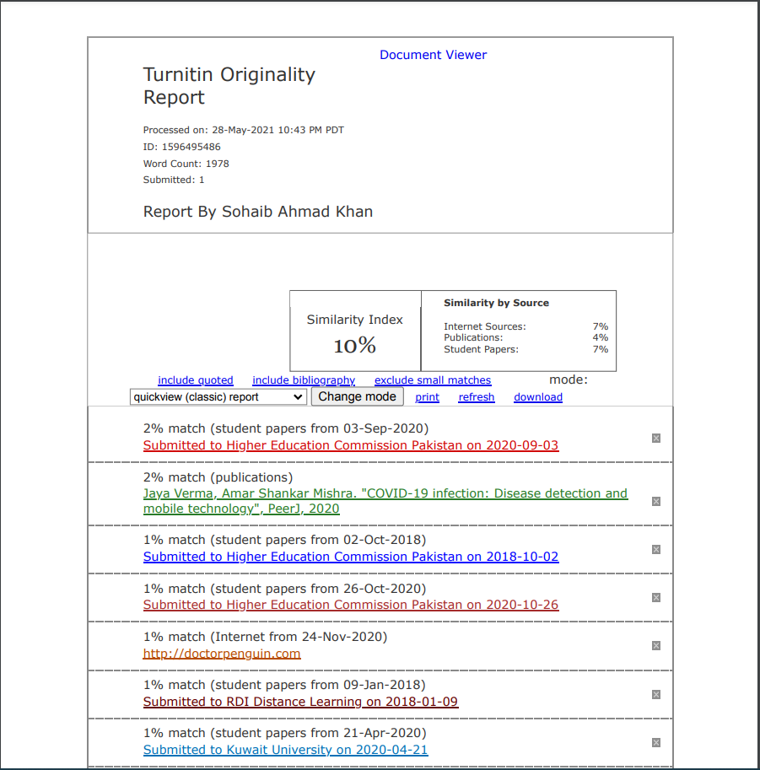

*Abstract*

1. Add statistics about covid and details about covid

2. symptoms of covid are good they can mostly be used as a guidance

3. Abstract can be extended by including statistics

*Introduction*

1. do not mention accuracy in scope and 94% is a very high call

Problem Statement:

1. explain the problem map it with earlier mentioned rular population

issue

2. Stats are good

*Problem Solution*

1. what will be use of chatbot it is conflicting, earlier it is used in

detection and here is used for cure of boredom

2. justify the use of chatbot and supporting features

3. explain the meeting medical specialist, will there be an appointment

system

*Related System*

1. Review them the app mentioned is only an alert app not a detection

app

2. Add more realted app consider global view

3. https://play.google.com/store/search?q=covid&c=apps&hl=en&gl=US

study from these

*Advantages*

1. The proposed system will save a lot of time and money by

not going through expensive lab tests that are not always true.

Will your system be 100% even for that one will have to have a test

swabs test are with a good accuracy

Modules:

1. Split module 1 into 2 one module deals with related set of

functionalities

2. any other preprocessing other than crop and resize?

3. no hint of result generation

4. Module how we feel how will you get heart rate sleep

pattrens body temps

5. Where will you obtain radius alert data

6. Module 3: 3.1 and 3.2 are same things why seperate

7. Module 6.4 : how will you get daily health tips any source

searched use of chart, will there be a diet management

*Software Process*

justify use of modified waterfall

mention selection between procedural and object oeriented

technology:

add xml as frontend

*Helpful Resources*

1. https://www.ncbi.nlm.nih.gov/pmc/articles/PMC7187882/

2. https://journals.sagepub.com/doi/full/10.1177/2472630320958376

3. https://www.pyimagesearch.com/2020/03/16/detecting-covid-19-in-x-ray-images-with-keras-tensorflow-and-deep-learning/